
Department of MCA

Subject:
Design Thinking Lab

PHASE 2 — DEFINE PHASE

Topic: Impact of Quick Commerce on Local Kirana Shops

Submitted By:

Student Name | USN
E. N Sirisha | 1RV25MC030
Sindhu T P | 1RV25MC095
Sinchana S | 1RV25MC094

Academic Year: 2025 – 2026

Project Guide
Dr. Divya T L

Introduction to the Define Phase
The Define Phase is the second stage of the Design Thinking process and serves as the critical bridge between understanding the user and generating ideas. In the preceding Empathy Phase, the team immersed itself in the evolving landscape of grocery and daily-essentials retail in Indian cities — exploring how young urban consumers navigate between quick-commerce apps and local kirana shops through persona development, empathy mapping, and stakeholder interviews.
The Define Phase now takes that raw understanding and, with the support of primary survey evidence gathered from 95 respondents, converts it into a single, sharply focused, human-centred problem statement that the rest of the project will be built upon. The guiding logic of this phase is convergence: where empathy work intentionally widens the team's field of view, the Define Phase narrows that breadth into actionable focusA structured survey was circulated to urban consumers across Bengaluru and surrounding regions. The 95 responses allow the team to test assumptions formed during the Empathy Phase against real data, to measure the relative severity of each issue, and to prioritise the problem space accordingly.
1.1 Objectives of Phase 2
To validate qualitative impressions from the Empathy Phase against quantitative survey evidence from real urban consumers.
- To understand the structure and interdependence of the problem through mind mapping.
- To define a precise Point-of-View (POV) problem statement and a set of "How Might We" questions to guide ideation.
- To propose an evidence-based direction that the Ideate, Prototype, and Test phases will develop further.
1.2 Tools Applied in This Phase
Three complementary tools are applied in sequence, each adding a different layer of rigour: Data Analysis (to quantify the problem from survey evidence), Mind Mapping (to expose the structure and interconnections of the problem space), and Affinity Mapping (to cluster insights into clear, actionable themes). The phase concludes with a defined problem statement and "How Might We" questions.
2. Data Analysis
Data Analysis is the process of organising, examining, and interpreting the survey information so that patterns, frequencies, and relationships become visible. While the Empathy Phase captured the emotional texture of the problem, data analysis grounds those impressions in measurable evidence — ensuring that the team's conclusions reflect what respondents actually reported rather than what the team assumed they would feel.
2.1 Survey Design and Methodology
A structured questionnaire of ten questions was designed and distributed digitally to urban consumers in Bengaluru and surrounding areas. The questionnaire mixed single-choice questions (to establish clear majorities) with multiple-select questions (to capture the full spread of concerns). Each question received 94–95 responses, giving a robust sample drawn primarily from the 18–35 demographic. The questions progressed from respondent profile (age, shopping channels) through usage patterns and motivations, to local shop pain points and improvement opportunities.
2.2 Respondent Profile (Q1) — Age Group Distribution
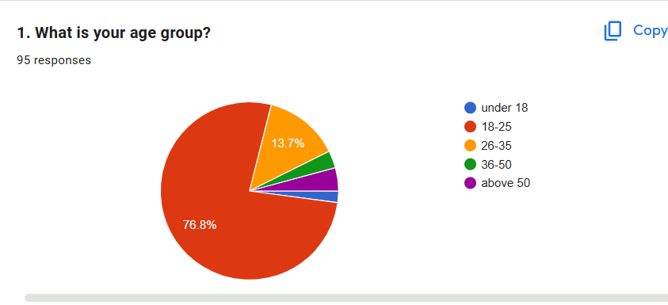
Figure 1 — Age group distribution of respondents (95 responses)
The survey skews decisively toward young adults: 76.8% of all 95 respondents fall in the 18–25 age bracket, making this cohort the defining voice of the dataset. The 26–35 group contributes 13.7%, while respondents under 18, aged 36–50, and above 50 collectively represent less than 10%. This demographic concentration is critical — any product or policy recommendation from this study primarily reflects the preferences of digitally-native Gen Z and younger Millennials who are equally comfortable with apps and physical shops.
2.3 Where Consumers Buy Groceries (Q2)
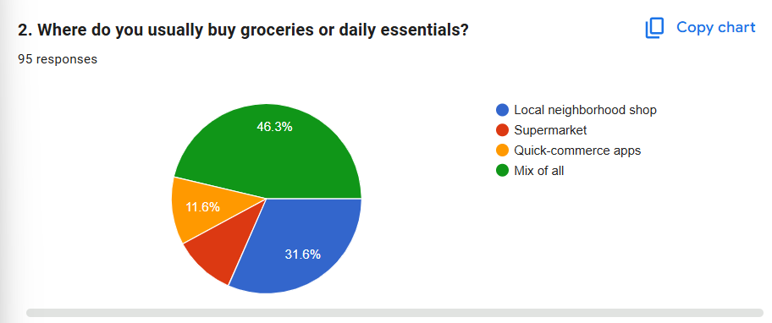
Figure 2 — Where respondents usually buy groceries or daily essentials (95 responses)
The channel distribution reveals that omnichannel behaviour is already the lived reality for nearly half of respondents:
- 46.3% use a Mix of All channels — they switch dynamically between shops, supermarkets, and apps based on situation
- 31.6% primarily use local neighbourhood shops — a substantial loyal segment for kirana retail
- 11.6% rely primarily on quick-commerce apps exclusively
- Supermarkets account for the remaining portion
Key insight: Nearly half of urban young adults do not commit to a single channel, suggesting price, convenience, and availability dynamically drive each purchase decision — rather than brand loyalty to any one retail format.

2.4 Frequency of Quick-Commerce App Usage (Q3)
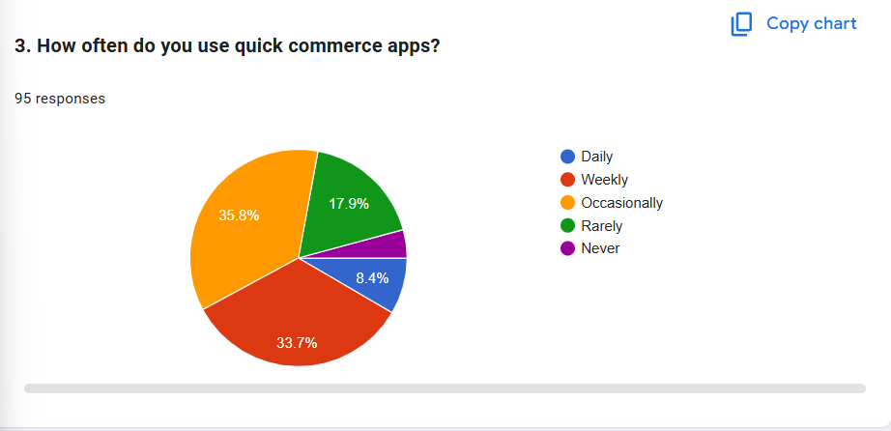
Figure 3 — How often respondents use quick-commerce apps (95 responses)
App usage is widespread, though habitual daily use remains a minority:
- 35.8% use apps occasionally — the largest segment, indicating situational rather than habitual adoption
- 33.7% use apps weekly — a strong habitual user base that is growing
- 17.9% rarely use apps — closer to the traditional-shopper end of the spectrum
- 8.4% are daily users — high-value, fully app-integrated consumers
- 4.2% never use apps — the holdout traditional shoppers
2.5 Main Reasons for Using Quick-Commerce Apps (Q4)
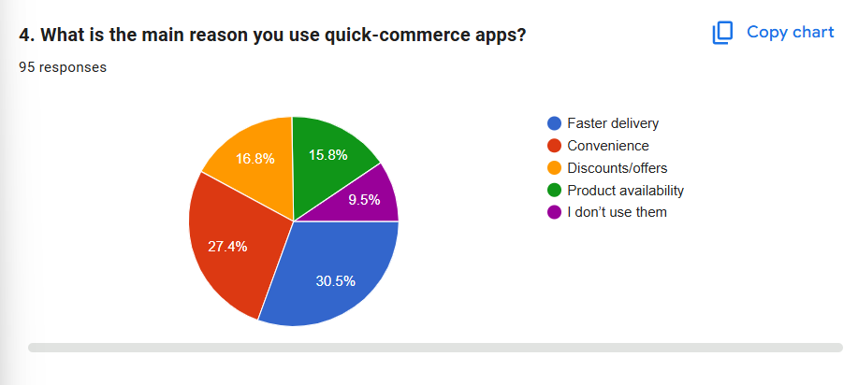
Figure 4 — Main reason respondents use quick-commerce apps (95 responses)
Speed and convenience together account for nearly 58% of stated motivations:
- 30.5% cite faster delivery as the primary driver — speed is the single most important value proposition
- 27.4% value convenience — reducing friction (no queues, no travel, doorstep delivery)
- 16.8% are motivated by discounts and offers — price sensitivity is real but secondary
- 15.8% choose apps for superior product availability and brand variety
- 9.5% state they do not use apps at all (consistent with Q3 never-users)
This finding directly implies the challenge for kirana shops: any digitisation effort must address delivery time and ordering ease to be competitive. Price discounts alone will not suffice.
2.6 Reasons for Still Shopping at Local Kirana Shops (Q5)
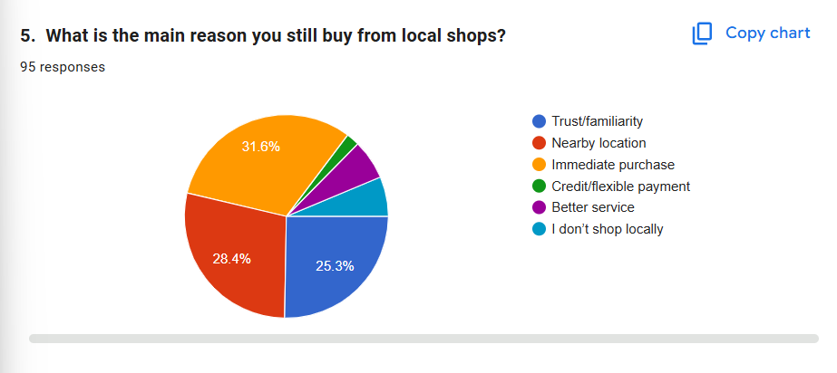
Figure 5 — Main reason respondents still buy from local shops (95 responses)
- 31.6% value immediate purchase — walk in and walk out with the product, no delivery wait
- 28.4% cite nearby location — walkable, zero delivery fee, zero minimum order
- 25.3% are driven by trust and familiarity with the shopkeeper — the community relationship
- Smaller segments value better personal service, flexible credit/khata system, or do not shop locally at all
Local shops retain loyalty through immediacy, proximity, and trust — three qualities that quick-commerce apps structurally struggle to replicate, especially the years-long trust built through community interaction.
2.7 Shift in Shopping Behaviour Over 2–3 Years (Q6)
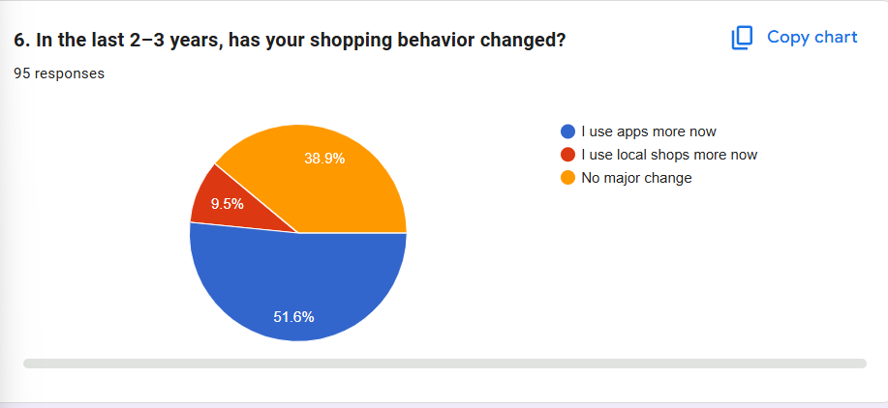
Figure 6 — How respondents' shopping behaviour has changed in the last 2–3 years (95 responses)
The behavioural shift toward apps is the single most significant trend in the dataset:
- 51.6% now use apps more — a clear majority reporting increased digital adoption
- 38.9% report no major change — a stable traditional segment that remains loyal to its current channels
- Only 9.5% use local shops more — a counter-trend worth noting but not dominant
Despite the app-usage surge, the 38.9% who report no change represent a potentially untapped market for hybrid solutions that bring digital convenience to the local shop format they already prefer.

2.8 Situations Where Apps Are Preferred (Q7)
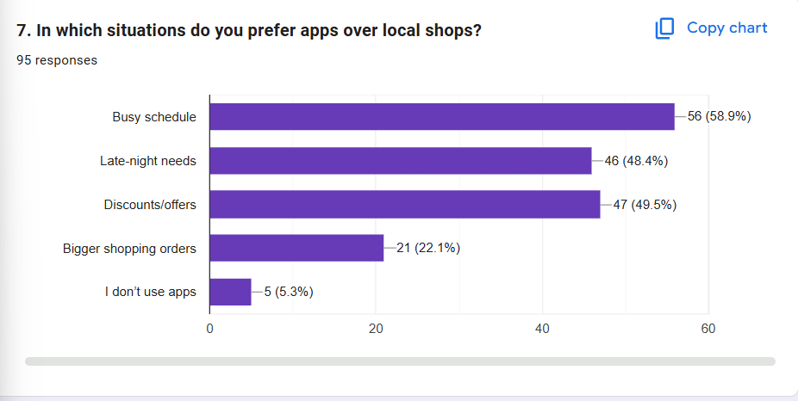Figure 7 — Situations in which respondents prefer apps over local shops (95 responses, multiple-select)
This multiple-select question reveals that app preference is strongly situational, not a categorical rejection of local shops:
- Busy schedule: 56 respondents (58.9%) — the dominant trigger; time pressure is the #1 reason to open an app
- Discounts/offers: 47 respondents (49.5%) — promotional pricing converts occasional users
- Late-night needs: 46 respondents (48.4%) — 24/7 availability is a structural advantage apps hold
- Bigger shopping orders: 21 respondents (22.1%) — bulk delivery convenience for heavy items
- 5 respondents (5.3%) say they never use apps at all
The data confirms that apps are contextual tools rather than permanent replacements. Time pressure and pricing incentives are the two dominant switching triggers — both are addressable by a digitally-enabled kirana shop.

2.9 Frustrations with Local Shops (Q8)
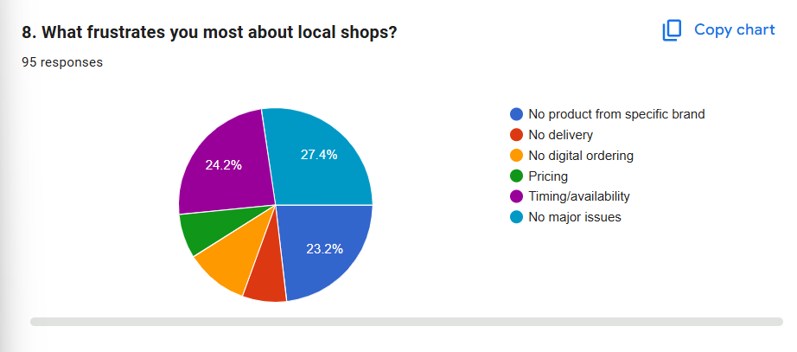
Figure 8 — What frustrates respondents most about local shops (95 responses)
Understanding what pushes consumers away from kiranas is as important as understanding what attracts them:
- 27.4% report no major issues — a reassuring baseline; local shops are not universally seen as broken
- 24.2% cite timing/availability as the top frustration — unpredictable opening hours and stock-outs
- 23.2% are frustrated by the absence of specific branded products — the long-tail inventory gap
- Smaller but notable frustrations: pricing competitiveness, no digital ordering option, no home delivery
Availability uncertainty and brand variety are the two operational gaps most likely to drive consumers toward apps. Both are solvable through light digitisation — WhatsApp catalogues, published hours — without requiring heavy technology investment.

2.10 Willingness to Use WhatsApp Ordering + Home Delivery from Local Shops (Q9)
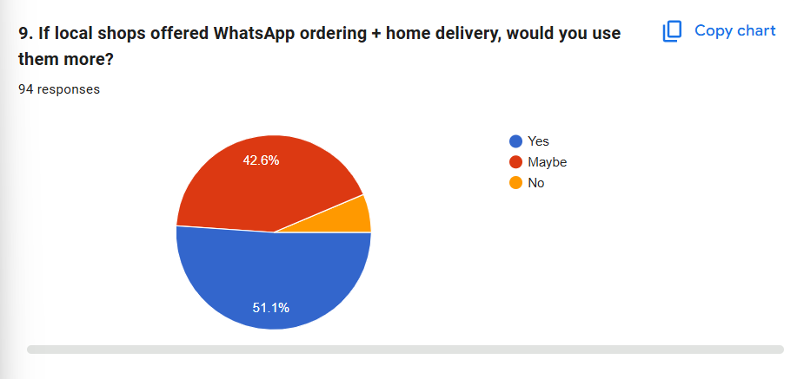
Figure 9 — Would respondents use local shops more if they offered WhatsApp ordering + home delivery? (94 responses)
This is the most strategically important data point in the entire survey:
- 51.1% answered Yes — a clear majority are ready to adopt a hybrid local-digital model
- 42.6% said Maybe — conditional interest, likely contingent on reliability and trust
- Only 6.3% said No — resistance to adoption is minimal
A combined 93.7% positive-or-open response directly validates a product concept that bridges kirana shop trust with quick-commerce convenience. This is a rare case where adoption appetite far exceeds typical innovation-curve expectations.
2.11 Synthesis of Quantitative Insights
Read as a whole, the survey tells a coherent and actionable story. Quick-commerce apps are winning on speed and convenience — particularly in time-pressured, late-night, and promotional contexts. Local kirana shops retain loyalty through immediacy, proximity, and community trust — but are losing ground due to availability uncertainty, brand variety gaps, and zero digital presence. The path forward is not for kiranas to "become apps" but to add a thin digital layer — WhatsApp ordering, published hours, basic delivery — that closes the gap without abandoning their core strengths.

Survey Data Summary
Question | Key Metric | Implication for Kirana Shops
Q1 — Age of Respondents | 76.8% aged 18–25 | Solutions must serve a mobile-first, app-literate audience
Q2 — Shopping Channel | 46.3% use mix of all channels | Omnichannel is the default; no single-channel loyalty
Q3 — App Use Frequency | 42.1% use apps weekly or more | Apps are habitual for nearly half the sample
Q4 — Why Apps? | 58% cite speed + convenience | Delivery time and ordering ease are the core battleground
Q5 — Why Local Shops? | 31.6% value immediate purchase | Instant ownership is the kirana's unique advantage
Q6 — Behaviour Shift | 51.6% use apps more now | Structural drift toward digital is underway
Q7 — When Apps Win | 58.9% — busy schedule trigger | Time-saving context is the #1 switching moment
Q8 — Kirana Frustrations | 24.2% timing/availability | Predictable hours and stock visibility are fixable gaps
Q9 — WhatsApp Delivery | 93.7% Yes or Maybe | The hybrid local-digital model has clear market demand

3. Mind Mapping
Mind Mapping is a visual technique for exploring the structure of a problem by placing the central issue at the centre and radiating out its contributing factors, sub-factors, and interconnections. Where data analysis quantifies individual data points, the mind map exposes the hierarchy and relationships within and across those themes — helping the team see the quick-commerce and kirana problem as an interconnected system rather than a flat list of observations.
The mind map below places "Impact of Quick Commerce on Local Kirana Shops" at the centre and branches into six survey-validated dimensions — Consumer Profile, App Motivations, App Triggers, Kirana Strengths, Kirana Pain Points, and Digital Opportunity — each broken down into specific, observable sub-problems drawn directly from the survey data.
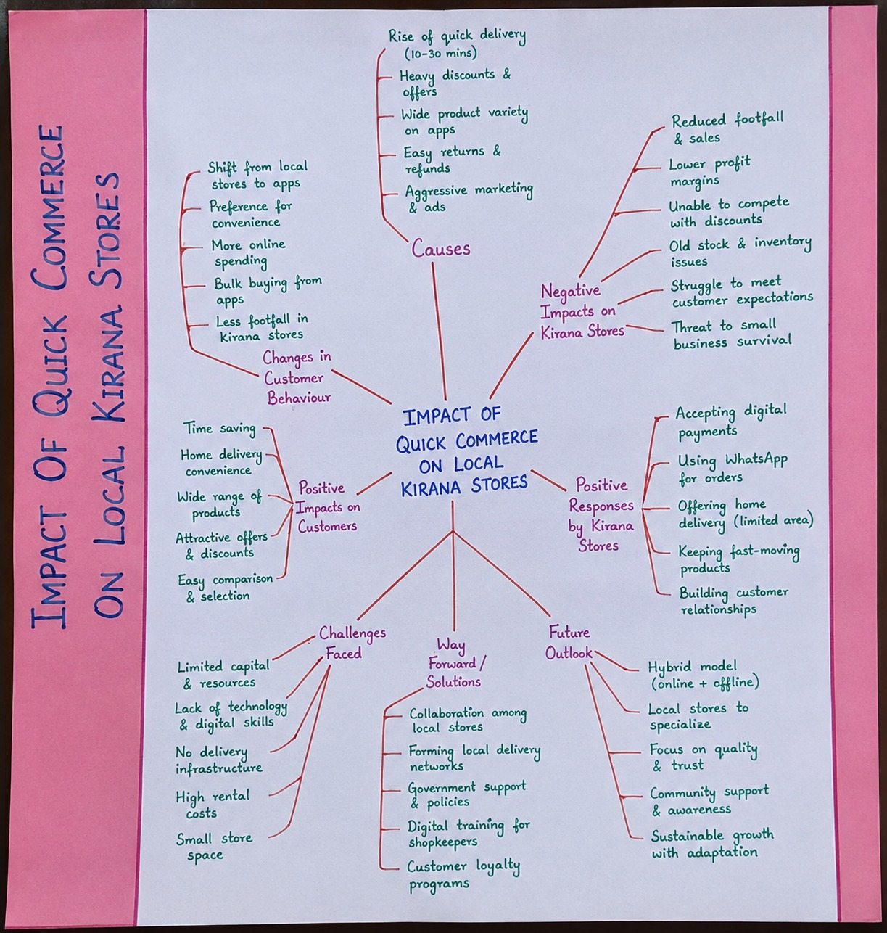
Figure 10 — Mind map of the quick commerce vs. kirana problem space and its sub-factors

3.1 The Six Branches of the Mind Map
Branch 1: Consumer Profile
The survey audience is predominantly young (76.8% aged 18–25), digitally fluent, and already omnichannel in behaviour (46.3% use a mix of all channels). This is not a consumer segment choosing between digital and physical retail — they switch fluidly between both, driven by context. The 51.6% who report using apps more than 2–3 years ago confirm that this migration is accelerating.
Branch 2: App Motivations
Two motivations dominate: faster delivery (30.5%) and convenience (27.4%). Together they account for nearly 58% of app usage reasons. Discounts (16.8%) and product availability (15.8%) are secondary but significant. This creates a clear target for kirana digitisation: if a local shop can offer ordered delivery and make the process frictionless, it addresses the primary reasons consumers currently choose apps.
Branch 3: When Apps Win — Situational Triggers
App preference is situational rather than categorical. The three dominant triggers are: busy schedule (58.9%), discount availability (49.5%), and late-night need (48.4%). These are context-specific moments, not permanent rejections of local shops. A kirana offering WhatsApp ordering for scheduled delivery and extended hours can recapture a substantial portion of this demand.
Branch 4: Kirana Strengths
Local shops retain three structural advantages that apps cannot easily replicate: immediacy of purchase (31.6%), proximity and zero delivery cost (28.4%), and trust/community familiarity (25.3%). These are not peripheral — they are the reasons 31.6% of the sample continues to rely primarily on kiranas despite the availability of apps. Any solution must preserve these strengths rather than replace them.
Branch 5: Kirana Pain Points
The data identifies two operational failures that drive consumers to apps: timing and availability uncertainty (24.2%) and specific brand unavailability (23.2%). These are not fundamental structural problems — they are solvable operational gaps. Publishing opening hours on WhatsApp or Google, and maintaining a basic digital catalogue, directly addresses both without requiring significant capital investment.
Branch 6: Digital Opportunity
The clearest signal in the dataset is the 93.7% of respondents who are open to or interested in WhatsApp ordering and home delivery from their local kirana. This branch of the mind map represents the convergence point — where the consumer's willingness to adopt meets the kirana's opportunity to compete. The gap between current kirana reality and consumer expectation is precisely the space where a solution can operate.
3.2 What the Mind Map Reveals
The mind map makes two things clear. First, the problem is genuinely multi-dimensional: kiranas are not failing because of a single flaw, but because of a cluster of small, addressable operational and visibility gaps. Second, several branches converge on a common opportunity — the digital interface layer. Adding a lightweight digital presence (WhatsApp, published hours, delivery coordination) allows kiranas to retain all their structural strengths while addressing the primary reasons consumers currently switch to apps.

4. Affinity Mapping
Affinity Mapping is a bottom-up sense-making technique in which individual observations, quotes, and data points are written onto separate notes and then grouped by natural similarity. Rather than imposing categories in advance, the team allows themes to emerge from the data itself. This approach guards against the team's preconceptions and ensures that the resulting categories genuinely reflect the consumer's and shopkeeper's reality as expressed in the survey.
Working from the nine survey questions alongside interview insights and empathy map observations, the team generated dozens of individual insight notes and clustered them by affinity. Five clear, mutually reinforcing themes emerged, each grounded in specific survey evidence.

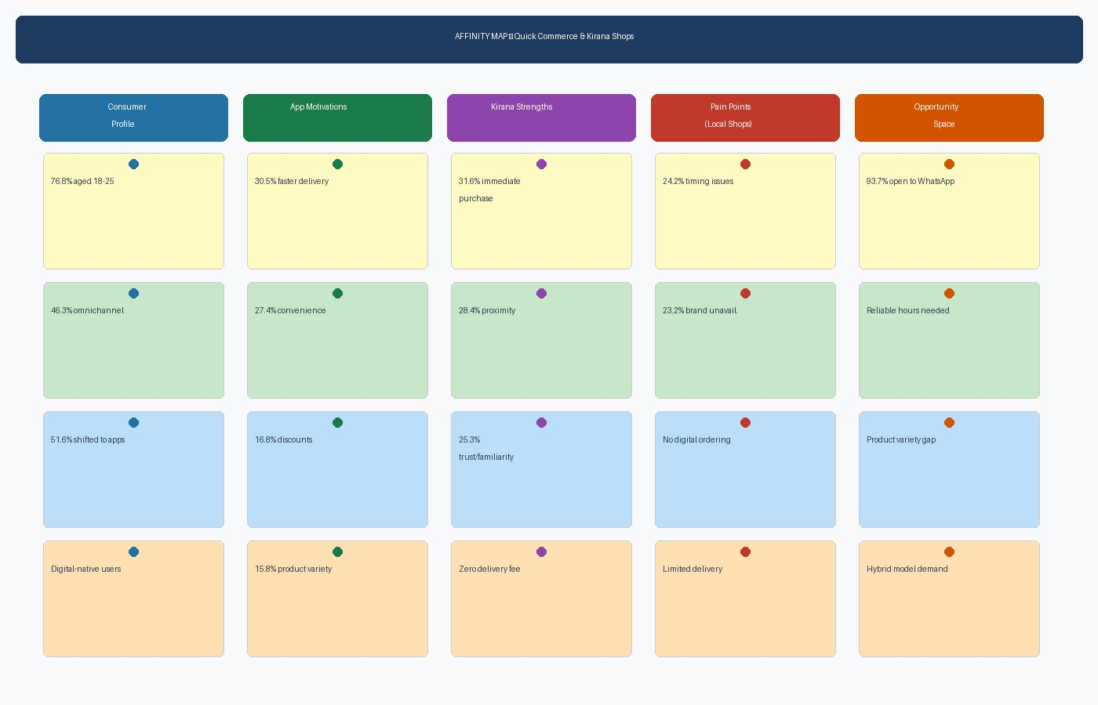
Figure 11 — Affinity map clustering survey and empathy insights into five themes

4.1 The Five Emergent Themes
Theme 1: Digital-Native Consumer Profile

Evidence: 76.8% aged 18–25; 46.3% omnichannel; 51.6% shifted to apps in 2–3 years.
This theme establishes who the user is. The dominant consumer segment is young, mobile-first, and already comfortable switching between channels. They are not ideologically committed to either apps or kiranas — they are pragmatic optimisers who choose the channel that best serves their need in that moment. Any solution must fit into this fluid, context-driven behaviour.

Theme 2: App Pull Factors — Speed, Convenience, and Price

Evidence: 30.5% faster delivery; 27.4% convenience; 16.8% discounts; 49.5% use apps during sales.
Quick-commerce apps have built their user base on a simple, repeatable value proposition: order in seconds, receive in minutes, sometimes at a discount. The 58% who cite speed and convenience together represent an audience that has been trained to expect near-instant fulfilment. This is the bar that any alternative must aspire to reach — not by matching every feature, but by meeting the core need (fast, easy, reliable) in the kirana's own way.

Theme 3: Kirana Structural Strengths — Immediacy, Proximity, and Trust

Evidence: 31.6% immediate purchase; 28.4% nearby location; 25.3% trust and familiarity.
Local kirana shops possess strengths that no app can fully replicate. The physical proximity means zero delivery fee and zero wait for the consumer who walks in and walks out. The community relationship — built over years of daily transactions, credit extension, and personal greeting — creates a level of trust that is structurally absent in an app interaction. These are not nostalgic preferences; they are rational, enduring advantages that define the kirana's competitive position.

Theme 4: Kirana Operational Gaps — Availability, Visibility, and Brand Variety

Evidence: 24.2% timing/availability frustration; 23.2% specific brand unavailability; no digital ordering.
The two most cited kirana frustrations — unpredictable hours and limited brand selection — are operational problems, not structural ones. A kirana cannot change its rent or location easily, but it can publish its opening hours on WhatsApp status, maintain a basic digital product list, and partner with a distributor to widen its range. The operational gap is real but narrow — and closing it would remove the most frequently cited reasons for switching to apps.

Theme 5: Hybrid Model Opportunity — The Digital Layer

Evidence: 93.7% open to WhatsApp ordering + home delivery; Q10 open responses requesting reliability and variety.
The fifth theme is the clearest design signal in the entire dataset. When consumers are asked whether they would use their local kirana more if it offered WhatsApp ordering and home delivery, 93.7% say yes or maybe. This is not a niche preference — it is a near-universal statement of latent demand. The "digital layer" theme emerges from this cluster: consumers do not want kiranas to stop being kiranas; they want kiranas to add the thin digital interface that makes them as easy to access as an app.
4.2 How the Five Themes Interlock
The five affinity themes are not independent silos — they form an interconnected system. A consumer who values kirana trust and proximity (Theme 3) but switches to an app because of a busy schedule (Theme 2) would return to the kirana if it offered WhatsApp ordering (Theme 5). The operational gaps (Theme 4) exist against the backdrop of a digital-native consumer (Theme 1) who has been trained by apps to expect visibility and ease. Closing the operational and visibility gaps is therefore not just a nice-to-have: it is the necessary condition for the kirana to retain its loyal base while recapturing the switchers.

5. Defined Problem Statement
With the data analysed, insights clustered through affinity mapping, and the problem space structured through mind mapping, the team can now articulate a precise, human-centred problem statement. In Design Thinking this is expressed first as a Point-of-View (POV) statement — built from the user, their need, and the key insight — and then opened up into a set of "How Might We" (HMW) questions that reframe the problem as an invitation to design.
5.1 Point-of-View Statement

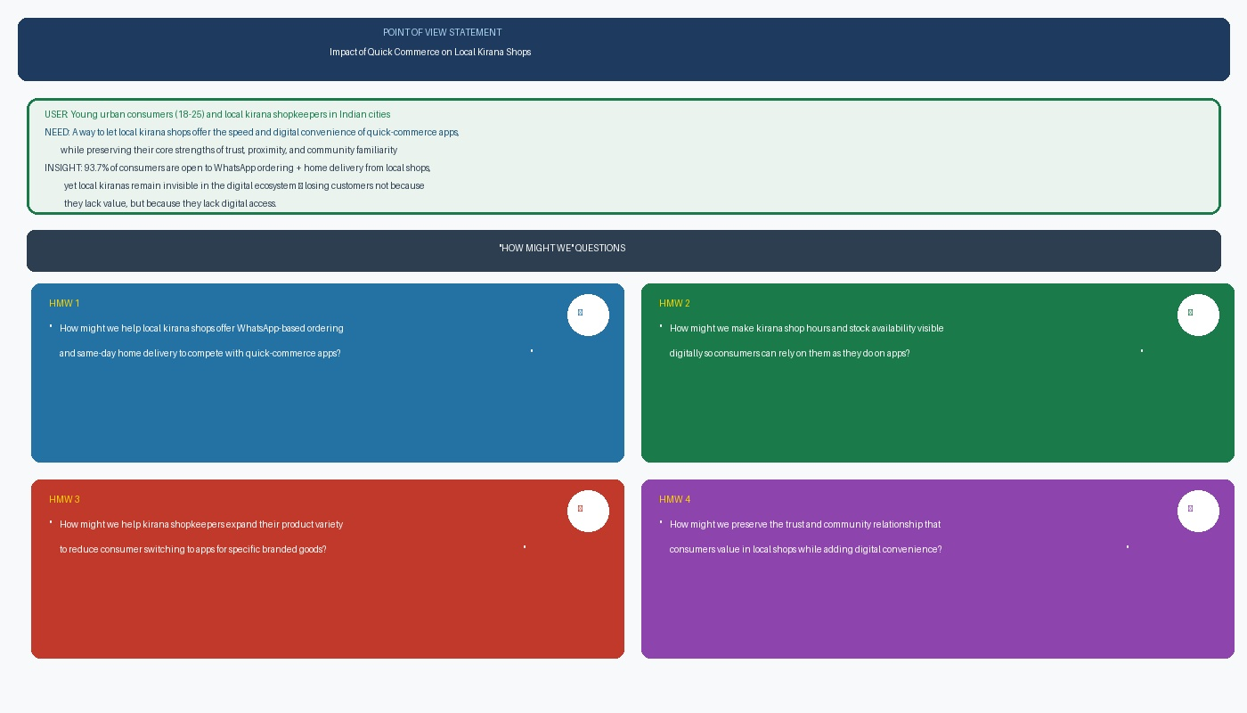
Figure 12 — Point-of-View statement and resulting "How Might We" questions

FINAL PROBLEM STATEMENT

USER: Young urban consumers (18–25) in Indian cities who currently split their shopping between
local kirana shops and quick-commerce apps based on situational need.

NEED: A way to access the speed, convenience, and digital ordering capability of quick-commerce
apps through their trusted local kirana shop — without losing the immediacy, proximity,
and community trust that already makes the kirana their first choice for many purchases.

INSIGHT: 93.7% of surveyed consumers are open to WhatsApp ordering and home delivery from local
shops, yet local kiranas remain invisible in the digital ecosystem — losing customers not
because they lack value, but because they lack a digital interface layer.

5.2 "How Might We" Questions
Reframing the problem statement as open questions gives the Ideate Phase clear, generative starting points, each tied directly to a survey-validated finding:

HMW 1 | How might we help local kirana shops offer WhatsApp-based ordering and same-day home delivery so that consumers can choose their trusted neighbourhood shop with the same ease as opening a quick-commerce app? (Q9 — 93.7% open to this)

HMW 2 | How might we make kirana shop opening hours and stock availability visible digitally so that consumers no longer switch to apps simply because they cannot be sure the shop is open or has what they need? (Q8 — 24.2% cite timing/availability as top frustration)

HMW 3 | How might we help local kirana shops expand their product variety and access to specific branded goods so that consumers do not need to switch to an app for the long-tail inventory it provides? (Q8 — 23.2% cite brand unavailability)

HMW 4 | How might we preserve and amplify the trust, familiarity, and community relationship that consumers already value in their local kirana shop while adding the thin digital layer that makes it as easy to use as an app? (Q5 — 85.3% cite immediacy, proximity, or trust as reasons for local shop loyalty)

5.3 Design Principles for the Solution
Before generating specific ideas, the team distilled the research into guiding design principles. These principles act as a filter in the Ideate Phase: any proposed idea should honour them.
- Kirana-preserving, not kirana-replacing — Solutions must enhance the local shop rather than substitute it, because the community relationship and physical immediacy are core assets, not liabilities.
- Lightweight and low-cost — Kirana shopkeepers operate on thin margins; any technology must be affordable, simple to adopt, and operable on a basic smartphone with no technical training.
- Consumer-first accessibility — The ordering and discovery experience must be as simple as sending a WhatsApp message; friction in adoption will kill uptake in a market already trained by apps.
- Reliability as the foundation — The single most damaging kirana perception is unreliability. Any solution must start with making the shop's hours, stock, and delivery commitments predictable and trustworthy.
- Works across neighbourhoods — Because the same gap exists across dense urban areas, the solution must not require a critical mass in a single location to function.

6. Possible Approach Towards a Solution
The Define Phase does not commit to a final solution — that is the work of the Ideate, Prototype, and Test phases. However, the convergence of the survey data, the affinity themes, and the mind map structure points strongly toward one direction. Consumers do not want kiranas to disappear or transform into apps; they want kiranas to add a thin digital interface layer — and 93.7% of them have already said they would use their local shop more if it did so.
The team has therefore provisionally framed a concept: a lightweight "Kirana Connect" platform — a WhatsApp-first ordering, catalogue, and delivery coordination tool designed specifically for neighbourhood kirana shops — that addresses the four highest-priority consumer needs identified in the survey without requiring the shopkeeper to make a significant capital investment.

6.1 The Four Proposed Modules
Module | What It Does | Survey Need Addressed | % Who Want This
WhatsApp Ordering | Customers place orders via WhatsApp; shop receives and confirms them; basic delivery or pickup coordination | Speed and convenience gap vs. apps (Q4) | 93.7% open (Q9)
Digital Catalogue & Hours | Shop publishes product list, prices, and opening hours on WhatsApp Business and Google; customers can check before visiting or ordering | Timing/availability frustration (Q8) | 24.2% cite this (Q8)
Brand Variety Network | Group sourcing with nearby kiranas to offer wider brand selection; shared distributor relationships | Brand unavailability frustration (Q8) | 23.2% cite this (Q8)
Trust Amplification | Digital reviews, order history, and consistent communication that reinforces the community trust consumers already feel | Trust and familiarity as loyalty driver (Q5) | 25.3% cite trust (Q5)

6.2 Desirability, Feasibility, and Impact
The concept scores well against the three classic lenses of design. It is desirable because every module answers a need consumers explicitly ranked highly in the survey — and 93.7% have already expressed intent to adopt. It is feasible because each module uses established, low-cost tools — WhatsApp Business, Google Business Profile, shared group purchasing — none of which requires unproven technology or large capital. It is impactful because it targets the exact gap the data reveals: the kirana's operational and visibility shortfalls — not its structural weaknesses.

DESIRED OUTCOME

To help local kirana shops reclaim their position as the primary daily essentials destination for
young urban consumers — not by out-competing quick-commerce apps on technology, but by adding
a lightweight digital layer over the trust, proximity, and immediacy that kiranas already provide
and that 93.7% of surveyed consumers have said they are ready to use.

7. Conclusion and Transition to the Ideate Phase
The Define Phase has successfully converged the broad empathy research into a single, evidence-backed focus. Data analysis of 95 survey responses quantified the problem and surfaced a critical finding: quick-commerce apps are not winning because of a fundamental failure in the kirana model, but because of a narrow, addressable gap in digital accessibility and operational visibility. 93.7% of consumers — the near-totality of the surveyed audience — have stated they would use their local kirana more if it offered WhatsApp ordering and home delivery.
Affinity mapping organised these findings into five clear themes — Consumer Profile, App Pull Factors, Kirana Strengths, Kirana Operational Gaps, and Digital Opportunity — each grounded in specific survey evidence. Mind mapping exposed the interconnections between these themes and confirmed that the problem is not a single, intractable structural failure but a cluster of small, solvable operational gaps sitting on top of a fundamentally strong foundation of community trust and physical proximity.
From this foundation, the team has defined a precise Point-of-View statement, four "How Might We" questions, a set of design principles, and a provisional concept direction — each shaped directly by what consumers themselves said they wanted.
The next phase, Ideate, will take the four How Might We questions and generate a wide range of specific solution ideas. The most promising will be prototyped and tested with both consumers and kirana shopkeepers, closing the Design Thinking loop and validating whether the proposed direction genuinely bridges the gap this phase has so carefully defined.

